EQ: ____________________________________________________________________________________

Activity # 1: Notes

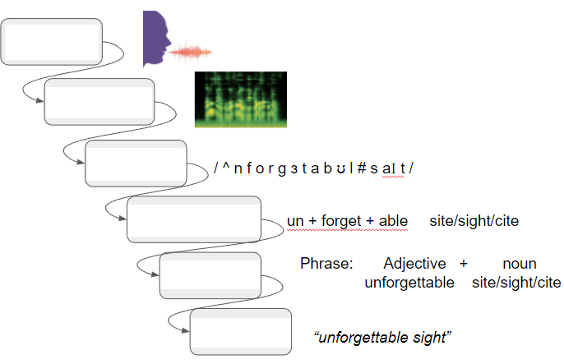  Vocabulary | Fill in the blanks based on the discussion and slides.
Sound:

Microphone:
Waveform:
Formants:

Activity #2: Spectrogram Word Match

Look at the spectrograms and try to match them to the correct phrase based on the pattern of frequency. Follow the link and say the words below. Write the letter number next to the correct sound, word, or phrase.

Say | Spectrogram
“Ssssssssssssss”
“Hello Hello Hello”
Turner Middle School”
“Zzzzzzzzzzzzzzzz”
“Puppy Puppy Puppy”
“Pushin P”

# | Spectrogram | # | Spectrogram
1 | 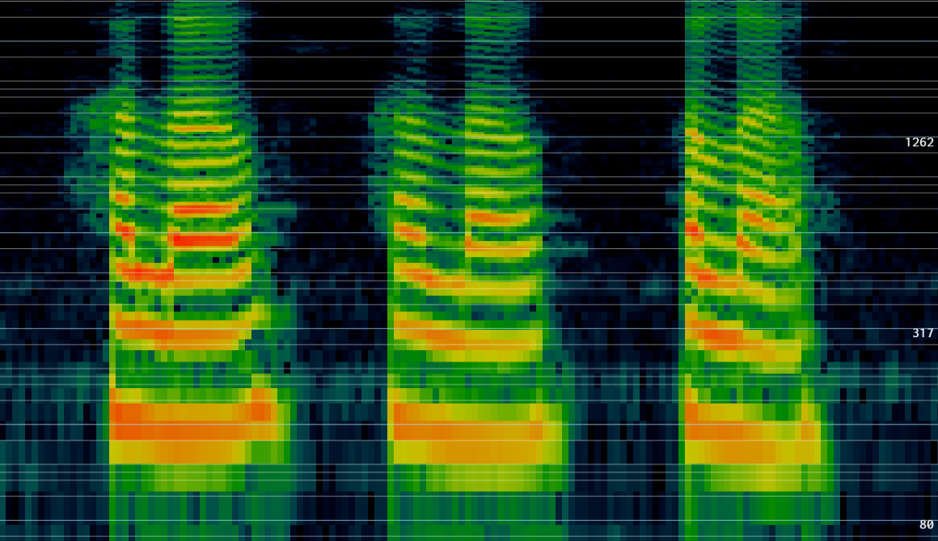 | 4 | 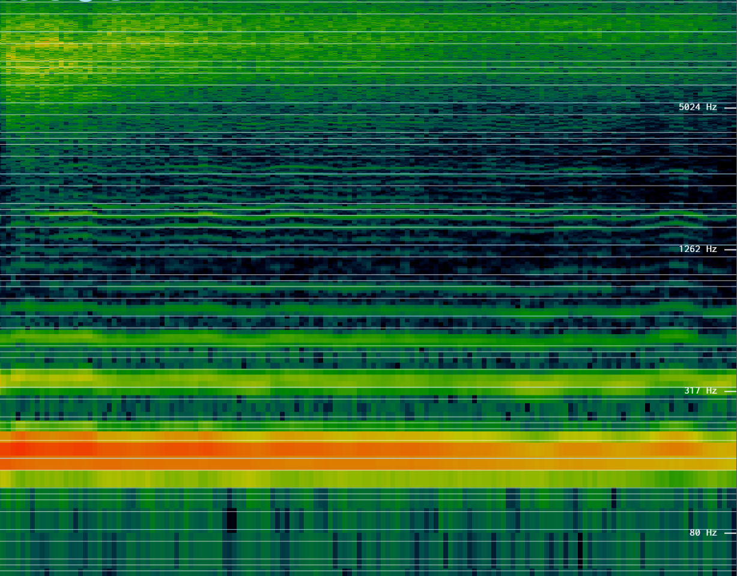
2 | 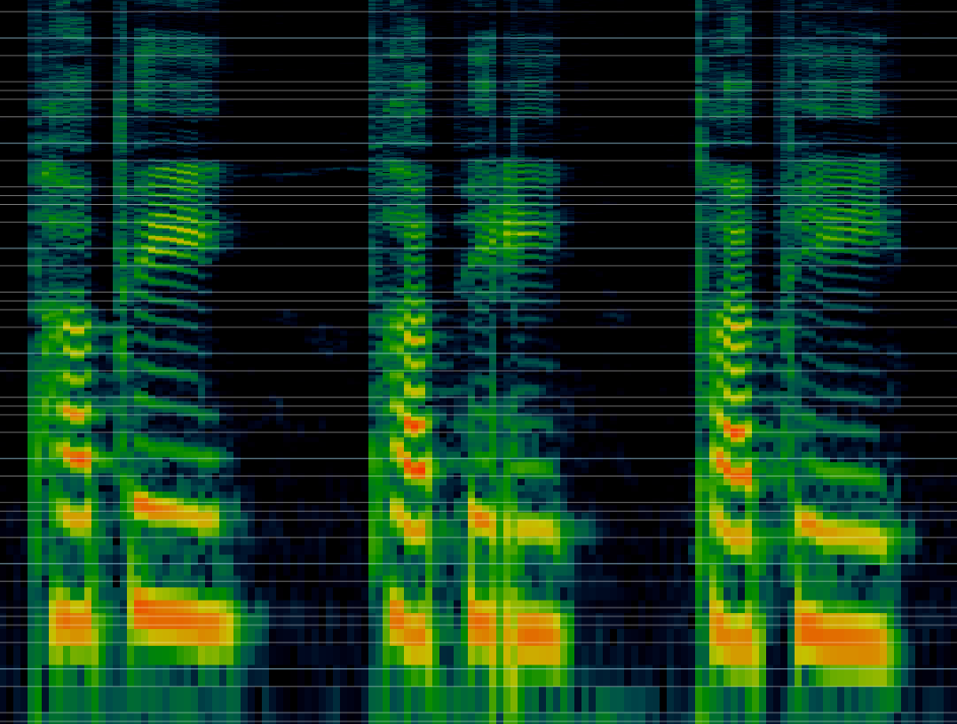 | 5 | 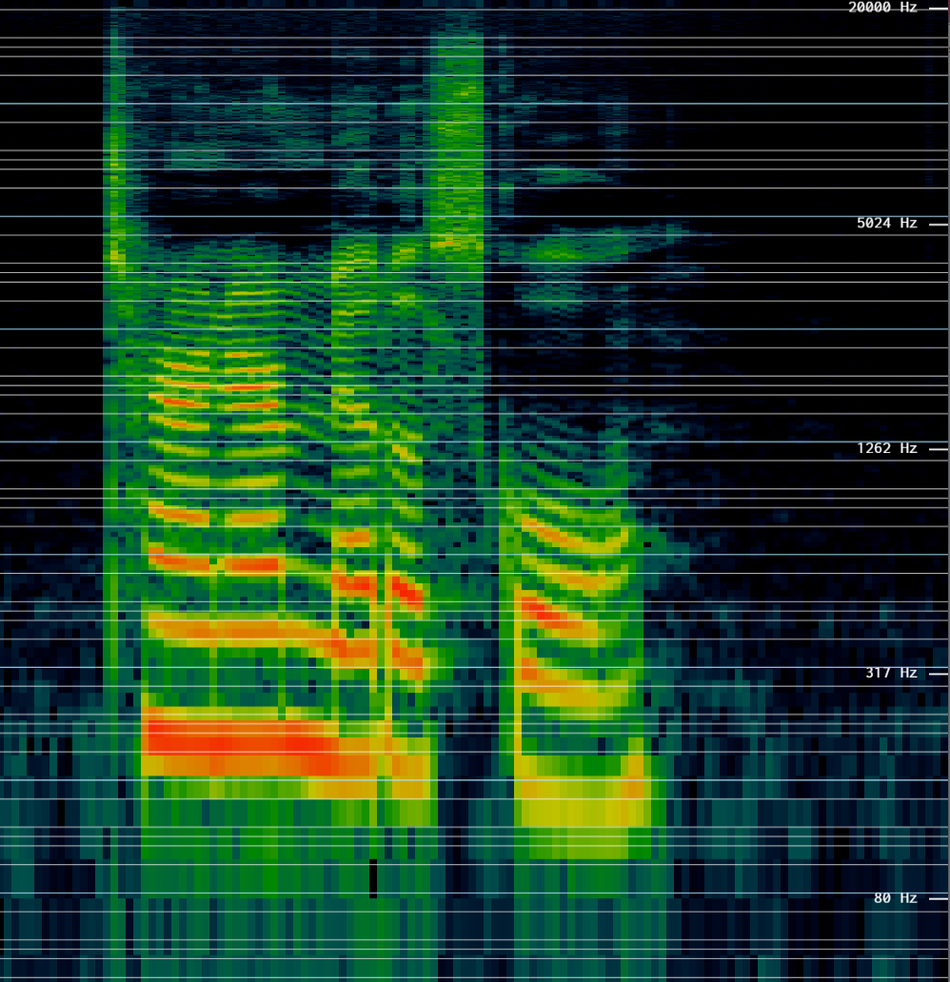
3 | 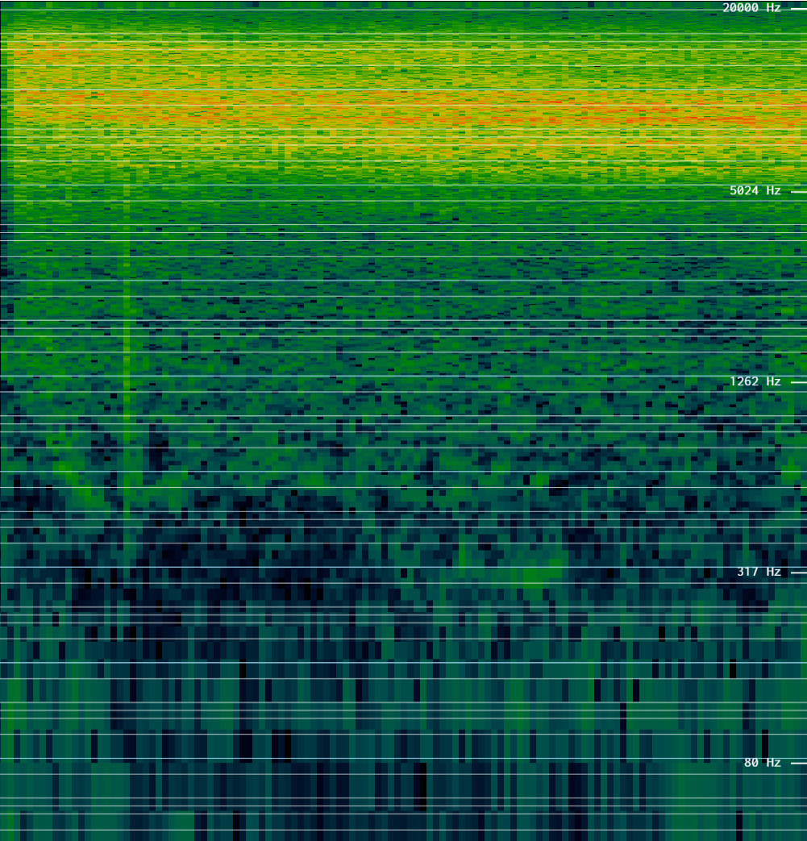 | 6 | 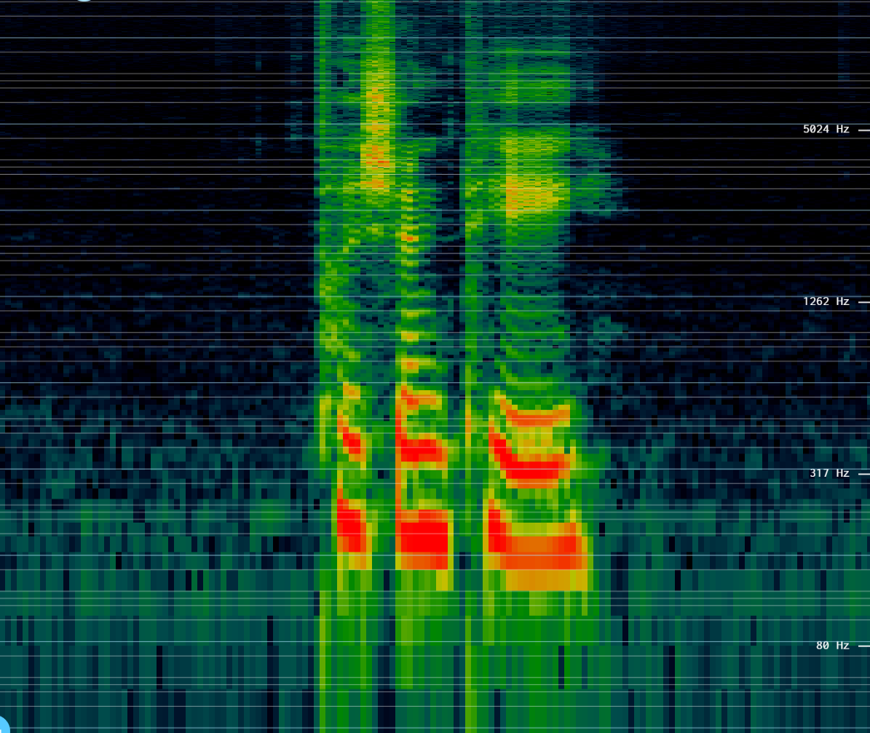

Activity 3: Speech Recognition Demo

In this activity you will test out a speech recognizer in chrome.
First, say the word to the speech recognizer by itself. Circle the TOP word it guesses.
Then, say the sentence to the speech recognizer. Read the first guess. Did it get the words correct?
Circle the word it guessed. | Say the whole sentence. | Did the speech recognizer guess correctly on its first try?
brake break | I told her if she didn't hit the brake in time she would break the garage door.
flour flower | You’ll need some flour to bake a flower-shaped cake.
knight night | The knight fought a dragon last night.
knight night | The brave knight fought the dragon last night.
Check the classroom for homophone pairs. Write your own homophone sentences.
Say your sentences to the computer. Did the computer get it correct?

Summarize: Write 2-3 sentences explaining how computers understand what we say.
________________________________________________________________________________________________________________________________________________________________________________________________________________________________________________________________________________________________________________________________________________________________________________________________________________________________________________________

